Particle 2D

(Particle 2D Editor)

installation
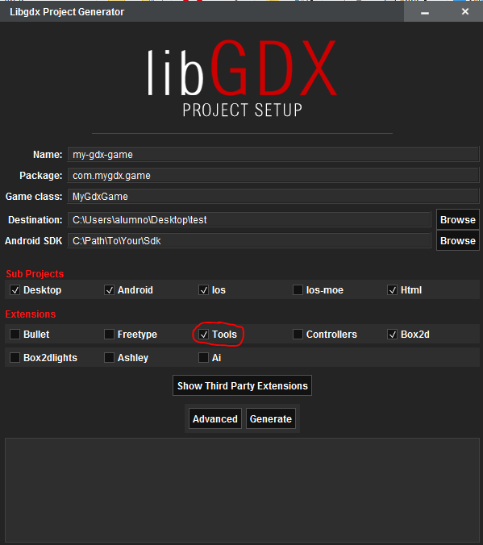
What We Need?
- In our case AndroidStudio
- A project of libgdx with the grandle 4.6 and with the option of tools checked

HOW TO START
We should go to External Libraries and run
ParticleEditor.Then we choose desktop in the option Use classpath of module
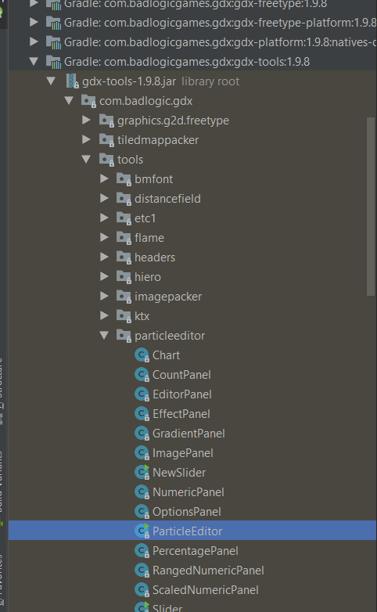
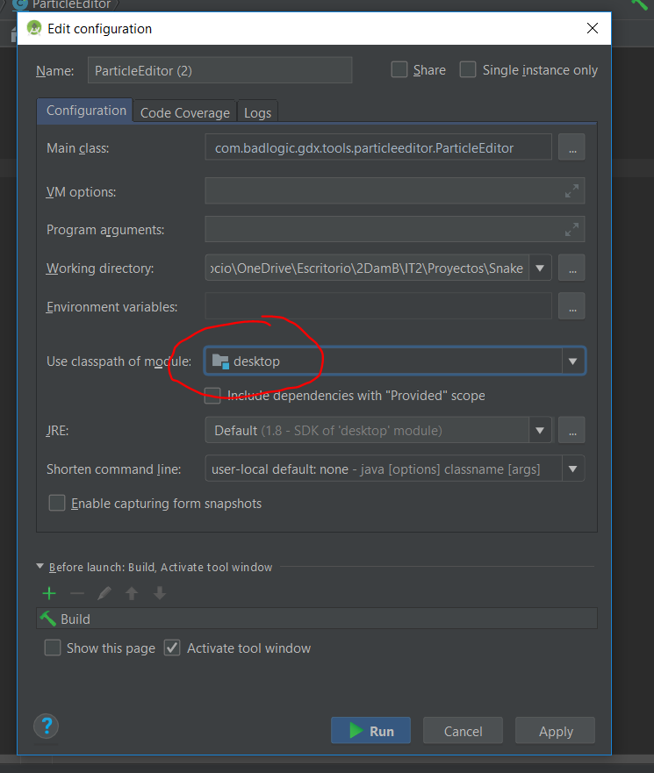

Particle 2d Editor features
EFFECT EMITTERS EDITOR PROPIETIES
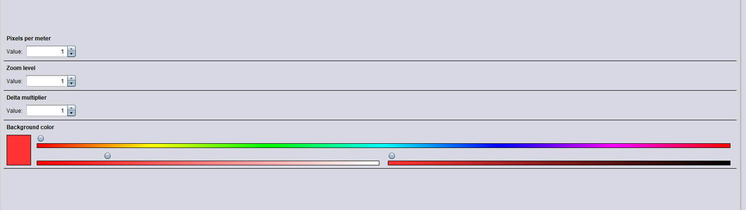
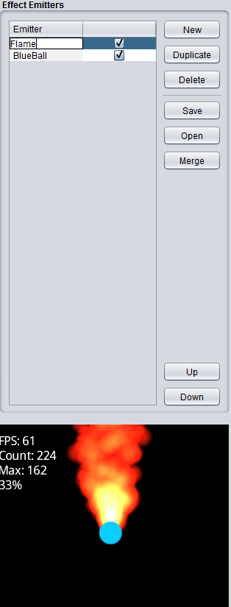

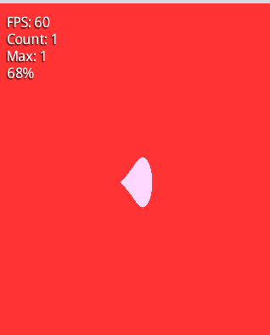
EMITTER PROPIETIES
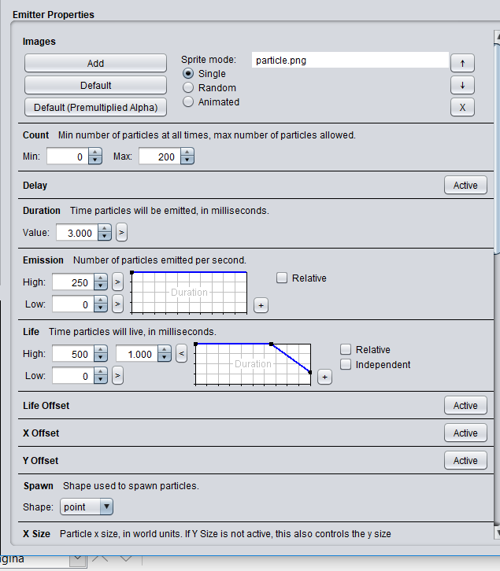
- Count: The count is used to define how many particles there should be at any time during the effect.

- Duration: The Duration is the value that sets how long the Effect runs. A duration of 1000 means the effect will last for 1 second.

- Spawn: This sets the shape of the area where particles can spawn.

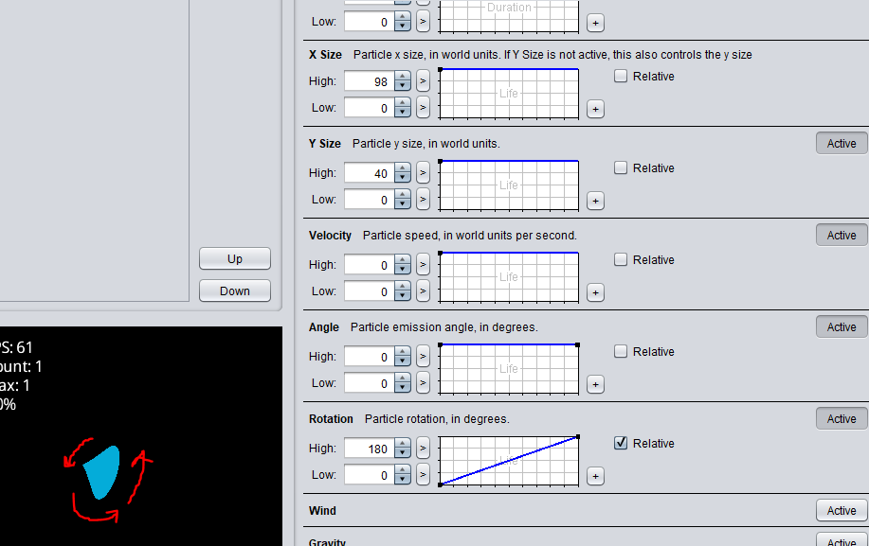
- Velocity: Speed of the particles.

- Angle: Sets the angle that particles go, the velocity mus be set.

- Rotation: Sets the rotation of the particle.

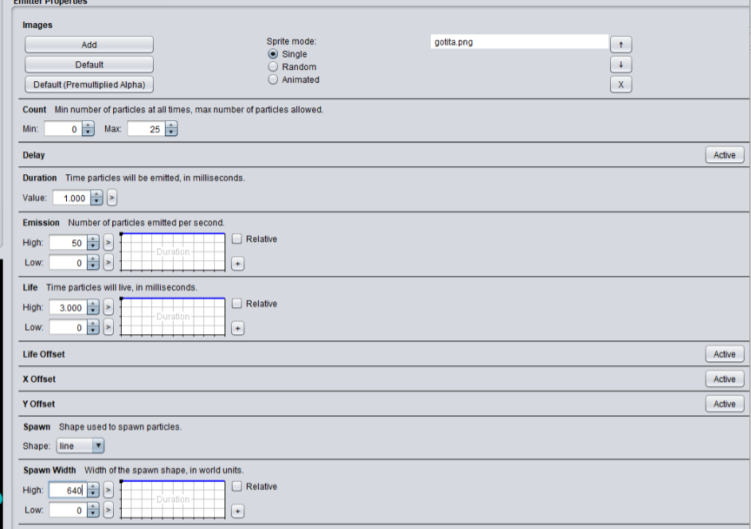
RAIN EXAMPLE
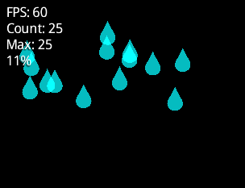

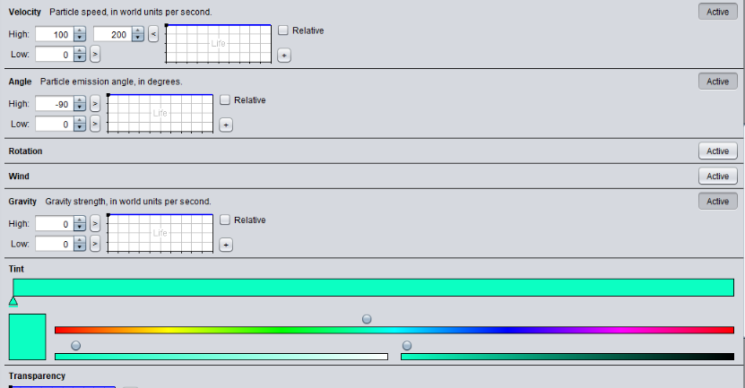
- Spawn shape is a line
- The width is 640 like our
WORLD_WIDTH.D_WIDTH.
- We change the direction
of the particles with a negative
angle.

import your particle to a project
- Step1:Save your project and and rename the extension *.p
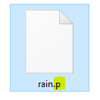
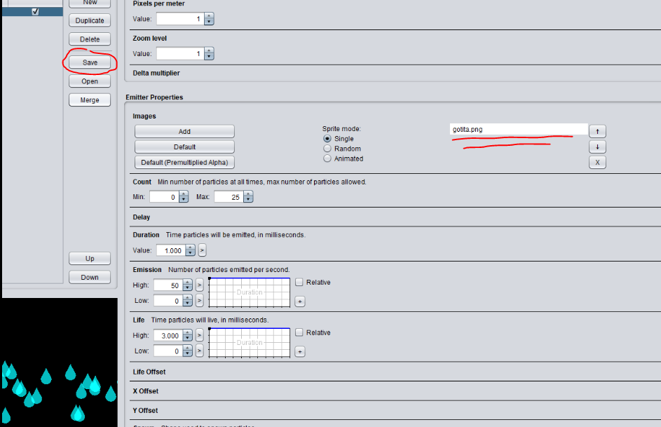

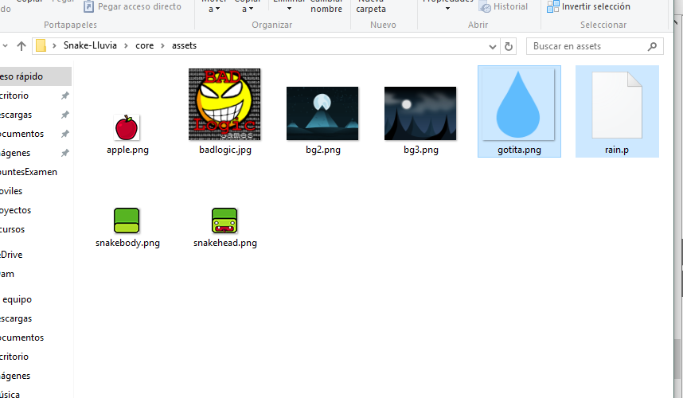
- Step2:Import the files to assets
- Step3: Create a object instance and initialize
private ParticleEffect particle = new ParticleEffect();

- Step4:Load the ParticleEffect in show() method,add its position and start it
particle.load(
Gdx.files.internal(“rain.p”),Gdx.files.internal(“”));

particle.getEmitters().first().setPosition(0,Gdx.graphics.getHeight());

particle.start();

- Step5:Draw Particle object in draw() method
batch.begin();
particle.draw(batch);
batch.end();

- Step6:Update the Particle object in render() method
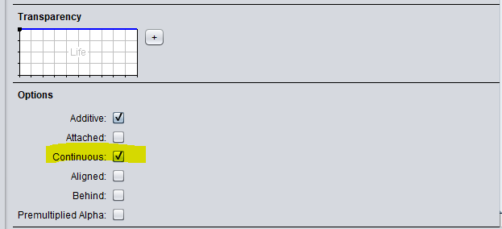
particle.update(delta);

It doesn’t work if we don’t defined
the emitter Continuous

SUMMARY
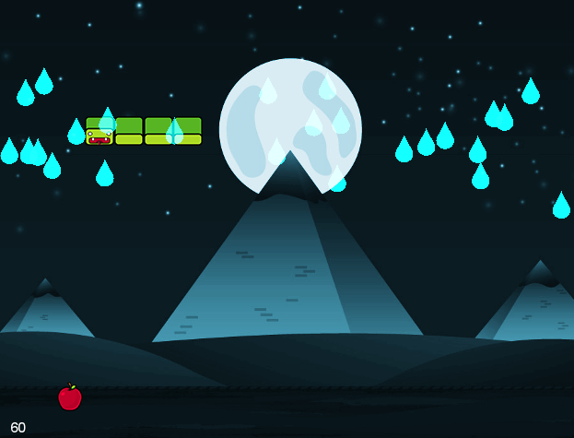
BIBLIOGRAPHY

http://perniadaniel.blogspot.com/2014/05/tutorial-particle-editor-libgdx.html

https://libgdx.badlogicgames.com/tools.html

https://www.gamedevelopment.blog/particle-effects-libgdx-2d/

